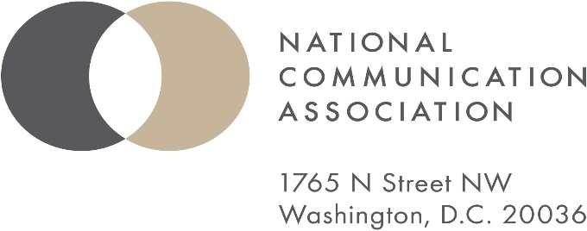

**AFFILIATE MEMORANDUM OF UNDERSTANDING**

The National Communication Association (NCA) encourages and sees great value in affiliating with other academic organizations. This document formalizes the terms of the partnership between NCA and the affiliating organization.

This Memorandum of Understanding (MOU) is an agreement between NCA, a Missouri benevolent association recognized as exempt from federal income tax under Section 501(c)(3) of the Internal Revenue Code and the affiliate listed below.

The effective date of this MOU shall be **January 1, 2025,** and expire on **December 31, 2029**, unless earlier terminated as set forth herein. If the affiliate organization wishes to continue its agreement with NCA, the affiliate organization will complete a reapplication process beginning one year prior to the expiration of this MOU. The parties agree that, with 30 day written notice, either party can terminate this MOU at any time.

This agreement shall define the relationship between the parties whereas, in furtherance of the parties’ purposes and in furtherance of NCA’s exempt purposes as a 501(c)(3) organization, the affiliate organization and NCA to collaborate to educate the public and to support and encourage those working in the field of communication, therefore, the parties to this MOU agree as follows:

1. NCA Agrees to
   1. List the name of the affiliate organization on the NCA website and include a link to the affiliate organization’s website.
   2. As determined by NCA, disseminate affiliate organization news and announcements through NCA’s electronic newsletter.
   3. Provide the affiliate organization, at no cost, a shared space in the exhibit area at the NCA Annual Convention for brochures and other information handouts for conference attendees, subject to NCA policies and procedures.
   4. ***Provide affiliate organization up to two guaranteed slots at the NCA annual convention, contingent upon affiliate organization following all the proper submission and scheduling procedures. The affiliate organization may request fewer slots from the National Office or apply for additional program slots through the NCA First Vice President.***
2. Affiliate organization agrees to
   1. Establish a link to NCA’s website on the affiliate organization’s website.
   2. Disseminate up to two messages a year written by NCA encouraging NCA membership and providing information about NCA resources through the affiliate organization’s regular member communication channels (e.g. newsletter, e-newsletter, blog post).
   3. Ensure participants in the affiliate organization program slots provided at the NCA Annual Convention are registered for the NCA Annual Convention.

For: For:

Organization Affiliate Organization

Printed Name Printed Name

Title Title

Signature Signature

_________________________ _________________________________

Date Date